Intelligent Voice Controlled Wheel

# Abstract

This paper describes intelligent voice-controlled wheelchair which operates on user’s voice commands.

The disabled people cannot move from one place to another on their own. They continuously need someone to help them in getting the wheelchair moving. This voice-controlled system makes them more independent.

A voice-controlled wheelchair can provide easy access for physical disabled person who cannot control their movements especially by hands. This voice-controlled wheelchair helps them to drive the wheelchair without anyone’s help. This system can be controlled by the simple voice commands given by the user.

The principle of the developed wheelchair consists of motor system, voice recognition module that would be controlled by the microcontroller.

# Keywords

Wheelchair, Voice control, Disabled people, Voice recognition,

Obstacle detection

# 1. INTRODUCTION

The voice commands to the wheelchair will be given by the mic placed as per the user comfort. The voice recognition will be done by voice recognition module.

The output from this module is then received by Arduino. The already written programs in the Arduino helps Arduino to convert this voice commands into considerable output and the wheelchair will move.

The basic movement functions includes forward and backward direction, left and right turns, stop, and water.

# 3. PROPOSED SYSTEM

This system works on voice commands given by the wheelchair user.

There are basically six commands, which command is given by the user, accordingly the wheelchair will move.

The voice commands of the user is recognized in the first step. Once it is recognized, the commands are converted into its equivalent instructions which drive the system. This system consists of two major modules namely Voice recognition module and motor driving module.

The output of this module is directed to Arduino which uses a motor driver IC to drive the motors.

The voice-controlled wheelchair works using mic, voice recognition module, Arduino and motors.

The input to the system is the unilateral mic. It is capable to take user’s voice commands and not bother about other noises.

The mic will be placed as per the user’s comfort. The output is in the form of voice signals and is transferred to the voice recognition module which acts as an interface between mic and Arduino.

The system is unable to understand any language other than binary code.

It is connected with motors to drive the wheelchair anywhere. Motors are responsible for the movement of wheelchair.

Hence, motors receive input from the Arduino and depending upon the instruction type, motors move accordingly.

This system uses two motors connected with motor driver. There are six different instructions that can be given to the motors, they are forward, backward, left, 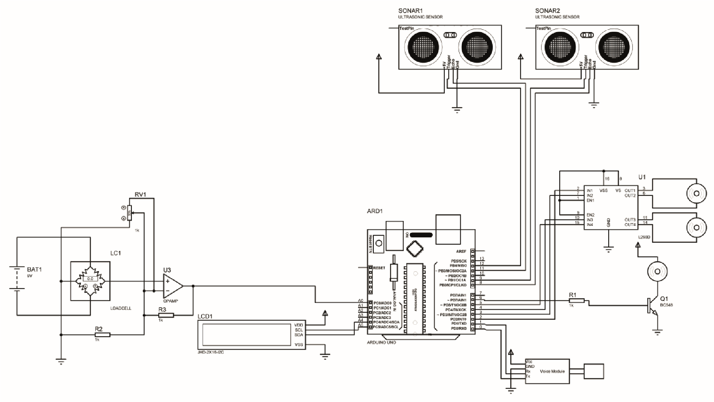right, stop and water.

# 4. WORKING METHODOLOGY

There are six types of commands in the wheelchair, Forward, Backward, Left, Right, Stop and Water.

The wheelchair will move when the power supply is given and the load is activated. For the forward command wheelchair will moves in Forward direction and two motors will rotates in forward direction.

For Backward command the wheelchair will moves in Backward direction and the two motors will rotates in backward direction.

For the Left command the right motor will rotates and the wheelchair moves towards left direction.

For Right command the Left motor will rotates and the wheelchair will move towards Right direction.

The Display unit displays the weight applied, and the commands which is given to the voice module.

The voice recognition module i. e., v3.1 is used to recognize the voice commands given by the user and it can be trained by the user. It’s a 48-pin single chip CMOS voice recognition LSI circuit with on-chip analogue front end. In this system, the Voice recognition module is trained and it takes the input from mic available in the system. The wheelchair uses the voice Recognition module interfaced with the Arduino Uno R3 to convert the voice commands into motor understandable Instructions to move the wheelchair as commanded by the user.

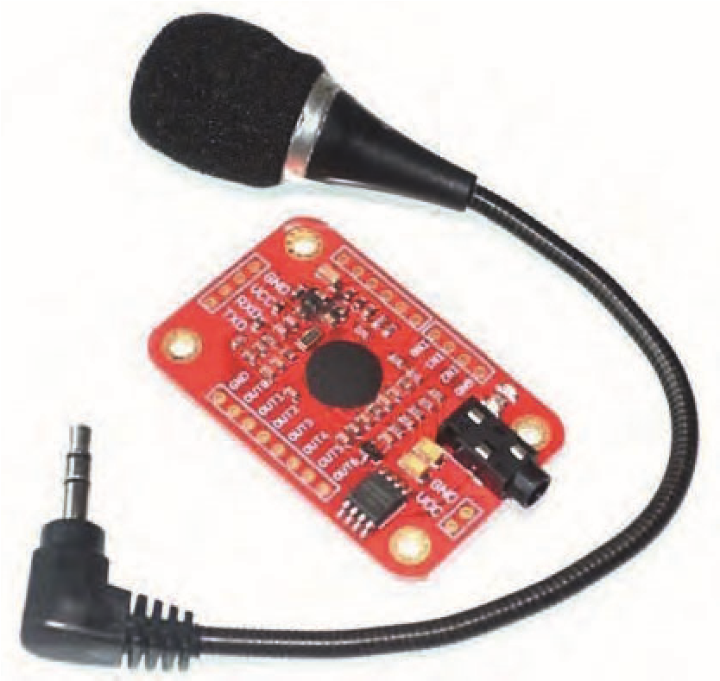

Load Cell

This straight bar load cell (sometimes called a strain gauge) can translate up to 20 kg of pressure (force) into an electrical signal. Each load cell is able to measure the electrical resistance that changes in response to, and proportional of, the strain (e. g., pressure or force) applied to the bar. With this gauge, you will be able to tell just how heavy an object is, if an object’s weight changes over time, or if you simply need to sense the presence of an object by measuring strain or load applied to a surface. This straight bar load cell is made from an aluminium alloy and is capable of reading a capacity of 2KG of weight

## 5. FUTURE SCOPE

This system will be a Real-Time Voice controlled Wheelchair for the physically disabled person. This system will Be designed to operate the wheelchair based on the voice of the user and control the movement according to the command Given by the operating person. The voice would be given through a unilateral mic and would be converted into binary Format by voice recognition kit. Thus, this binary format would be checked with the binary code fed to the microcontroller, if true the command will be performed. More specifically, this system is designed to allow an admin and users to give the Voice command to the wheelchair. This command would be performed within seconds. On the whole it’s basic operation Would be left, right, stop, go, and back. Basically, it’s a wheelchair controlled by voice.

## 6. CONCLUSION

1. The design and implementation of a voice-con-

trolled wheelchair for disabled people using Arduino and voice Recognition module for controlling the motion of a wheelchair is designed. The direction of the wheelchair now Can be selected using the specified voice commands.

1. The design not only reduce the manufacture cost compared with present market but also will give great Competitive with other types of electrical wheelchair. The only thing needed to ride the wheelchair is the synthetic Voice commands of the person.
2. A system that can directly enhanced the lifestyle of a physically disabled person in the community is Implemented. This project has many advantages like safety, comfort, energy saving, full automation etc.
3. The technology can also be enhanced safely for

users who use ordinary joystick-controlled wheelchair, by Preventing collision with walls, fixed objects,

Issue 26. February 2023 | Cardiometry | 535

furniture and other people. Thus, all the drawbacks of the joystick-Controlled wheelchair are overcome by this “voice-controlled wheelchair”

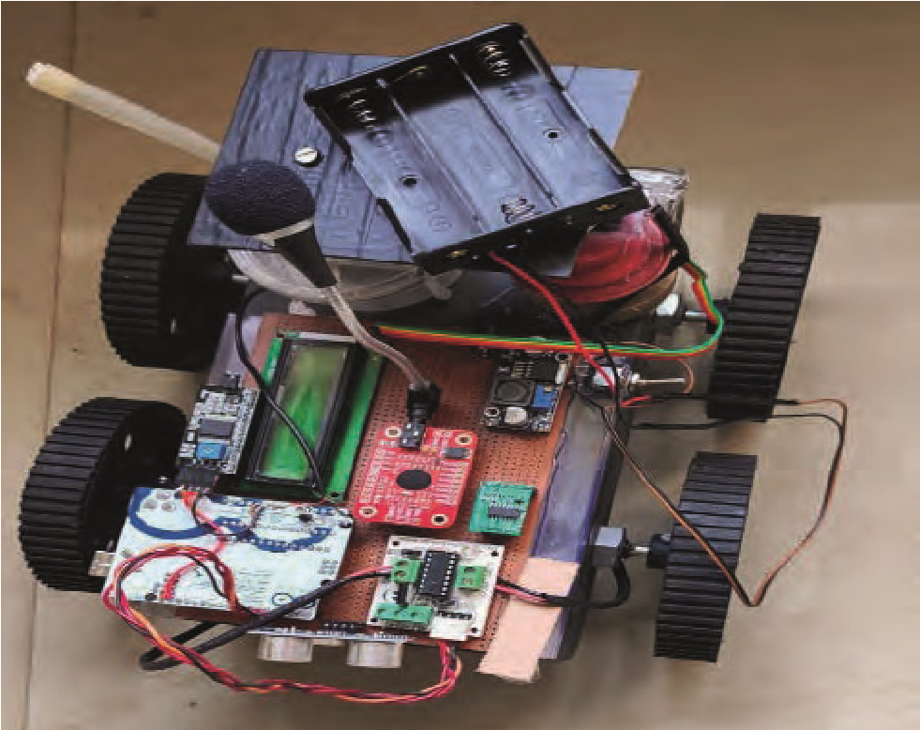

HARDWARE SET UP

## 7. RESULT AND DISCUSSION

The design construction and development of automatic voice-controlled wheelchair are done and shown in the figure. To verify the performance of wheelchair the relationship between Voice command, Motor drive, DC motor, Arduino are determined. The results of relationship between Voice command, Motor drive, DC motor and Arduino are display on the display unit. In addition, the ultrasonic sensor is tested to confirm the performance of obstacles detection system. These sensors are used to measure the distance between obstacles and wheelchair at 20 cm distance. The submersible pump is tested for the dispense of water for 2 second. The load results the movement of wheelchair when the load is activated.

# REFERENCES

1. Chotikunnan, B. Panomruttanarug, N. Thongpance, M. Sangworasil and T. Matsuura, “An application of Fuzzy Logic Reinforcement Iterative Learning Control to Balance a Wheelchair,” International Journal of Applied Biomedical Engineering, vol. 10, no. 2, 2017, pp. 1-9.
2. A. Murai, M. Mizuguchi, M. Nishimori, T. Saitoh, T. Osaki and R. Konishi, “Voice Activated Wheelchair with Collision Avoidance Using Sensor Information,” ICROS-SICE International Joint Conference, Fukuoka International Congress Center, Japan, pp. 4232-4237, August 2009.
3. L. M. Bergasa, M. Mazo, A. Gardel, R. Bareaand L. Boquete, “Commands generation by face movements applied to the Guidance of a wheelchair for handicapped people,” in Proc. Of International Conference on Pattern Recognition, vol.4, 2000, pp.4660–4663.
4. T. Saitoh, N. Takahashi and R. Konishi, “Development of an Intelligent wheelchair with visual oral motion,” in Proc. Of IEEE Int. Workshop on Robot and Human Communication, 2007, pp.145–150.
5. Y. Matsumoto, T. Ino and T. Ogasawara, “Development of Intelligent wheelchair system with face and gaze based interface,”In Proc. Of IEEE Int. Workshop on Robot and HumanCommunication, 2001, pp.262– 267.
6. Y. Ichinose, M. Wakumoto, K. Honda, T. Azuma and J. Satou,“Human interface using a wireless tongue-palate contact pressure Sensor system and its application to the control of an electric Wheelchair,” IEICE Trans. Inf. & Syst., vol.J86-D-II, no.2, 2003, pp.364–367.
7. K.-H. Kim, H. K. Kim, J.-S. Kim, W. Son and S.- Y. Lee, “A Bio signal-based human interface controlling a power-wheelchair For people with motor disabilities,” ETRI Journal, vol.28, no.1, 2006, pp.111–114.
8. K. Choi, M. Sato and Y. Koike, “Consideration of the Embodiment of a new, human-centered interface,” IEICE Trans. Inf. & Syst., vol.E89-D, no.6, 2006, pp.1826–1833.
9. R. Barea, L. Boquete, M. Mazo and E. Lopez, “Wheelchair Guidance strategies using EOG,” Journal of Intelligent and Robotic Systems, vol.34, no.3, 2002, pp.279–299.
10. S-.Y. Cho, A. P. Vinod and K.W.E. Cheng, “Towards a Brain Computer Interface Based Control for Next Generation Electric Wheelchairs”, 2009 3rd International Conference on Power Electronics Systems and Applications, Digital Reference: K210509123.
11. J. S. Lee, Y. W. Su, and C. C. Shen, “A comparative study of wireless protocols:Bluetooth, UWB, ZigBee and Wi-Fi,” in Proc. IEEE 33rd Annu. Conf.IECON, pp.46-51, Nov. 2007
12. Ala Al-Fuqaha, Mohsen Guizani, Mehdi Mohammadi,Mohammed Aledhari,and Moussa Ayyash, “Internet ofThings: A Survey on Enabling Technologies,Protocols, andApplications" IEEE Communication Surveys Tutorials,Vol.17, No. 4, Fourth Quarter 2015,pp. 2347-2377.

Reproduced with permission of copyright owner. Further reproduction prohibited without permission.